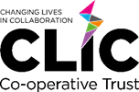

No Food Sharing Policy
Document Control
Date | 01/09/2026
Date of next review | July 2027
Supersedes | N/A
Amendments | N/A
Related Policies/Guidance | Allergen Policy, Personal Allergy Action Plan, Individual Health Care Plan, Allergy Risk Assessment, Pupils with Medical Needs Policy
Author | COO
Policy Category | MAT Wide
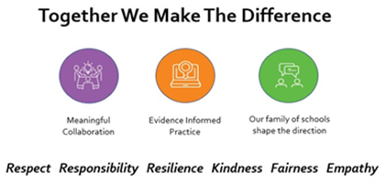

1. Purpose & Scope
This policy is established to guarantee a safe, healthy, and inclusive environment for all pupil and staff. It applies to all pupils, staff, parents, and visitors across all school grounds during normal operational hours, school trips, and extra-curricular activities.

2. Rationale
The school enforces a strict No Food Sharing policy because of:
- Life-Threatening Allergies: accidental exposure to severe allergens poses an immediate risk of anaphylaxis.
- Medical & Dietary Conditions: many pupils manage complex chronic conditions, such as Type 1 Diabetes, celiac disease, or severe food intolerances.
- Religious & Cultural Practices: the policy ensures families retain total control over food choices that align with their spiritual, cultural, or ethical beliefs.
- Infection Control: Halting the sharing of half-eaten food, drinks, and utensils significantly curbs the spread of communicable viruses and bacteria.

3. Responsibilities
3.1 Pupil Responsibilities
- Pupils must consume only the food and drinks provided by their own parents or carers or food from the school kitchen
- Trading, swapping, selling, or gifting any food item, snack, or drink is not allowed.
- Pupils must never share water bottles, drinking cups, straws, or eating utensils.

3.2 Parent & Carers Responsibilities
- Parents must ensure that packed lunches and snacks are clearly labelled with their child’s name.
- Parents must instruct their children on the importance of eating only their own food.
- Homemade baked goods or unlabelled food items are strictly barred from being brought to school to distribute to other children.

3.3 Classroom Celebrations & Birthdays
- Traditional food treats (eg, birthday cakes, cupcakes) are not permitted for classroom distribution.
- Alternatives for parents wishing to celebrate an event may send non-food items (eg, stickers)

4. School Safeguards & Compliance
- Supervision: lunchtime staff, teaching assistants, and playground staff will actively monitor pupils during snack and mealtimes to ensure compliance.
- Emergency Lunches: if a pupil forgets their lunch or loses their food, staff will advise the school canteen or school office to provide a safe alternative meal. Staff will never distribute leftover food from other pupils.
- Hand Hygiene: pupils must wash their hands with soap and water or use hand sanitizer both immediately before and after consuming food.
- All staff members will complete annual allergy awareness training.

